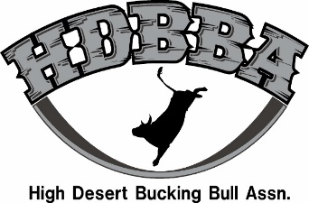
HDBBA 2021 ENTRY FORM

EVENT LOCATION____________________________ CLASS (circle one) Jr. 2yr 3yr 4yr Maturity
OWNER NAME______________________________________________
ABBI C0-SANCTIONED BULL (Circle Yes or No) If Yes ABBI Registration #:_________________________
BULL NAME______________________BULL ID (hip brand) # _____________CHUTE:(Circle One) Left or Right
BULL RIDER NAME_______________________________________________________________________
Contractor Provides Own Bull Rider
I, as an entering bull owner, have read and understand HDBBA guidelines. I assume all risk and danger incidental to the bull competitions and release HDBBA and their host sites, title sponsors, host organizations, participating owners, their animals, and all agents therefor from any and all liabilities resulting from such cases. Entering bull owners also recognize that the event producer has contracted professionals in the field of Judging and Veterinary Medicine and the decisions of those individuals contracted is final. I concede to any and all Rules, Regulations, Guidelines and Disclaimers printed in the HDBBA Guidelines and stated herein.
Payments and Entries due in office Sat.14 days before event. No Exceptions!!!
CURRENT Health and Brand papers are required At check-in, including proof of neg. TB and Brucellosis test
Included in fees: $15 office fee and $150 bull rider fee (3s, and 4s Only)
Jr. Futurity Bull $165.00
Futurity Bull (2 year old) $315.00
Derby Bull (3 year old) $565.00
Classic Bull (4 year old) $665.00
Maturity Bull $565.00
ABBI Co-Sanctioned Bull $100.00 | If applicable?
Total

Owners Signature:______________________________________________________________
Bull Nominated for Contractor of The Year (limit to 3 bulls nominated) Yes or No
(US FUNDS) check, money order, or credit card accepted. (may also pay online) Card charges will have a credit card fee. www.highdesertbulls.com

Mail to: HDBBA 16570 Alegre Way Caldwell Idaho 83607 Phone 208-550-0229

